Delivery Process – Finance One

<?xml version="1.0"?><DocumentMinutes xmlns:xsi="http://www.w3.org/2001/XMLSchema-instance" xmlns:xsd="http://www.w3.org/2001/XMLSchema"> <GraphicCharterDefinitionId>0</GraphicCharterDefinitionId> <TemplateBaseTypeId>0</TemplateBaseTypeId> <CompanyId>1</CompanyId> <ConfidentialId>3</ConfidentialId> <ConfidentialDescription>Internal Use Only</ConfidentialDescription> <CountryId>0</CountryId> <PageSizeId>1</PageSizeId> <PageOrientationId>1</PageOrientationId> <PrePrintedStationary>false</PrePrintedStationary> <Project>Essbase SmartView Migration</Project> <Reference>20160314-080334-WU</Reference> <TemplateType>5</TemplateType> <CultureId>en-GB</CultureId> <LanguageId>1</LanguageId> <Customer>SI SOPRA STERIA</Customer> <DocumentDate>2019-11-20T10:57:56.936908+05:30</DocumentDate> <Saved>true</Saved> <IsValid>true</IsValid> <FirstPageCover>false</FirstPageCover> <IsNew>false</IsNew> <DateCreated>2016-03-14T12:49:34.6081861+05:30</DateCreated> <DisplayTableOfContents>true</DisplayTableOfContents> <Entity>054</Entity> <Subject>Internal Process</Subject> <Author>Christine Donce</Author> <TemplateName>Minutes</TemplateName> <Recipient>Aditi SHARMA &lt;aditi.sharma2@soprasteria.com&gt;; Mayank KAUSHIK &lt;mayank.kaushik@soprasteria.com&gt;</Recipient> <RecipientCC>Jean-Pierre LE PARC &lt;jean-pierre.leparc@soprasteria.com&gt;;

Laurence DELAMARE &lt;laurence.delamare@soprasteria.com&gt;

</RecipientCC></DocumentMinutes>

Summary

1. Introduction 3

2. Directory Structure and File Transfers 3

3. User Voice and Stories 3

4. Testing 4

4.1. Creation 4

4.2. Execution 5

5. GIT 6

5.1. GIT Installation 6

5.2. Repository Links: 9

5.3. Check in Process : 9

1. Different GIT directories as available for each module on the server as well as on your machine when you clone it. 9

a. ACE Delivery 13

i. Pre-Requisites 13

ii. File Headers 13

iii. Uploading file and creating Patches 16

iv. Applying RFC 18

b. Delivery Sheet 20

c. MD070 documentations 23

d. FileZilla Setup 23

# Introduction

This document gives an overview on the delivery process followed for a component on completion of its development.

# Directory Structure and File Transfers

FileZilla is the software used for file transfer between client and server.

There are four environments used as application:

* [SERAEBSDE1](https://support.oracle.com/epmos/faces/OnDemandEnvAccess?_adf.ctrl-state=11znfluwke_4&_afrLoop=341598639294813) (development environment)
* [SERAEBSDE2](https://support.oracle.com/epmos/faces/OnDemandEnvAccess?_adf.ctrl-state=11znfluwke_4&_afrLoop=341598639294813) (Integration environment)
* [SERAEBSTST](https://support.oracle.com/epmos/faces/OnDemandEnvAccess?_adf.ctrl-state=11znfluwke_4&_afrLoop=341598639294813) (User Testing environment)
* [SERAEBSPRD](https://support.oracle.com/epmos/faces/OnDemandEnvAccess?_adf.ctrl-state=11znfluwke_4&_afrLoop=341598639294813) (Production environment)

In FileZilla, two users need to be configured with server type SFTP:

* J_SERA01 *(Development Environments )* Host Name - omcscbajvyhvqo.opc.oracleoutsourcing.com – This user caters to all the non-prod environments *viz.* DSERAI (development)/DSER1I(integration)/TSERAI(UAT)
* I_SERA01 (Production environment) Host Name - omcscbatgsqrgb.opc.oracleoutsourcing.com

On connecting to the environments, all the code and AOL objects are placed in a zip file with their name as object version number under their module specific folders present in ‘/interface/j_sera01/DSERAI/src/livraison’ (where, user may be j_sera01/i_sera01 and environment may be DSERAI/DSER1I/TSERAI/PSERAI based on requirement).

# User Voice and Stories

1. User Voices are created in MOA OFA, directly by the users or by Nantes teams in Application OFA. User Voices for incidents can be created by any team member as needed on Application OFA. User Voice gives a broad description of requirements by the user.
2. For each user voice Nantes OFA team members would create one or many User Story in New status on ISSG/OFA. The MD050 document shall be placed and updated in Document IS. User Story is
3. The Initial test case  is created by the person who creates the User Story and link it to the user story
4. The User Story would be assigned to Indian SPOC , who shall assign it to the developers and change it to **ready**, when the developer picks up to work on it and changes the status to **active**.
5. Developer also adds the Component specific number like #AP059 as tag, for Indian deliveries we will add an extra #OFA-India.
6. An ACE Patch is created for each delivery and all the components should be checked in on GIT.
7. Once the development is complete , we  perform the test campaign and modify it in case needed . The testing should be performed on DSERAI and DSER1I Env , by Indian team before delivery. All relevant screen shot or  files  should be attached on the test case.
8. Initialize the Delivery document excel sheet
9. For any user story following are required to promote it in **resolve** status :
   1. Completed Test Case
   2. Changed components uploaded on GIT
   3. ACE patch on DSERAI and DSER1I
   4. MD070 if required

# Testing

## Creation

All Test Cases are created on VSTS Test Plans . <https://soprasteria-is.visualstudio.com/ISSSG/_testManagement/mine>

A Test Case is created for each specific, with all required test steps.

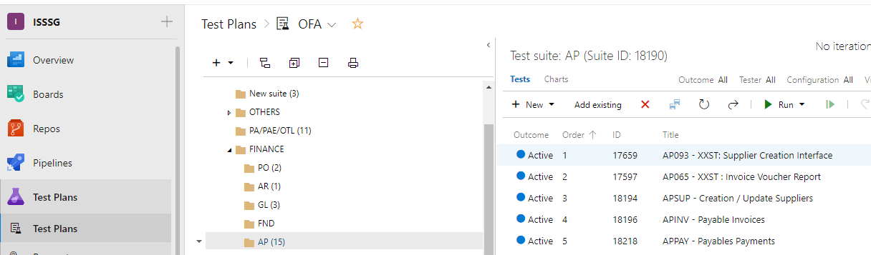

For each user story a test Campaign is created linking to the user story. All relevant Test cases are associated to this new Campaign Test Suit

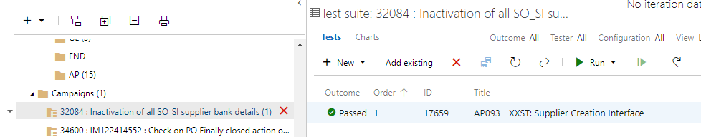

## Execution

To run the Test Case open the Test case on Campaigns and click on Run Button

This will pop-up a Test Runner (You might need an Add-in which you can allow to install)

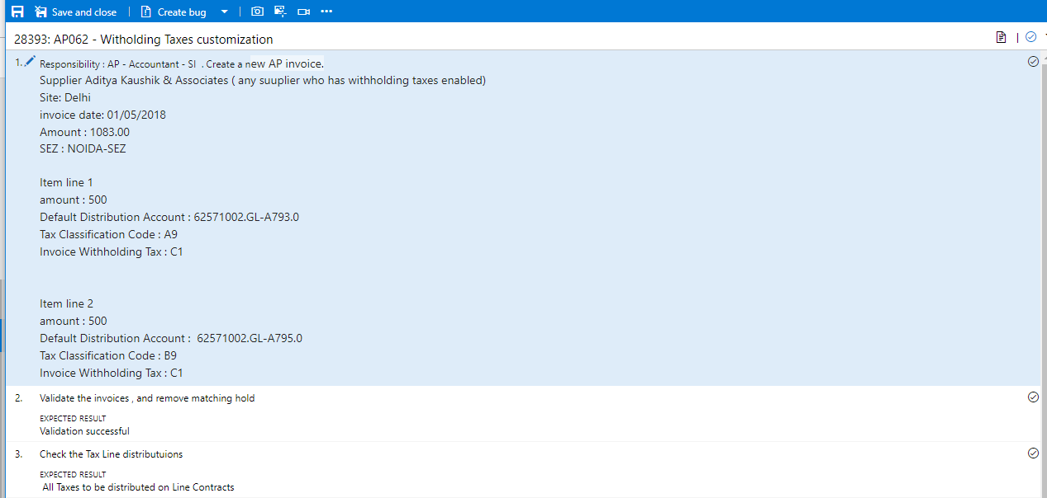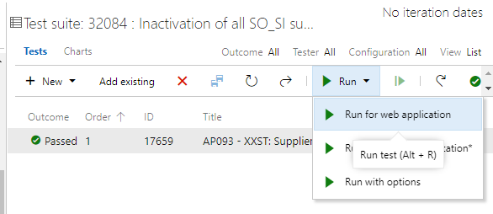Perform each step mentioned on the Test Case one by one . Files and screen shots can be attached with each case

When all test steps are successful , test case can be passed or failed accordingly

# GIT

## GIT Installation

Install GIT on your individual desktop. There are 2 components needed  to use GIT  :

1. GIT
2. Tortoise GIT  - Interface used to connect GIT and perform actions.

The software for GIT can be found at following location :

PreRequisite : Git for Windows <https://gitforwindows.org/>   
Download TortoiseGIT tool on <https://tortoisegit.org/>

More details are provided on following Wiki : <https://soprasteria-is.visualstudio.com/ISSSG/_wiki/wikis/ISSSG.wiki?pagePath=%2FWiki%20Architecture%2FGIT%2FTortoiseGIT%20Use&wikiVersion=GBwikiMaster>

While installing Tortoise GIT you shall be asked to select the credential type , please use manger – current Window user. Rest all the settings can be left to default.

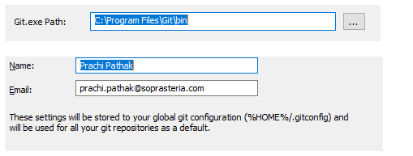

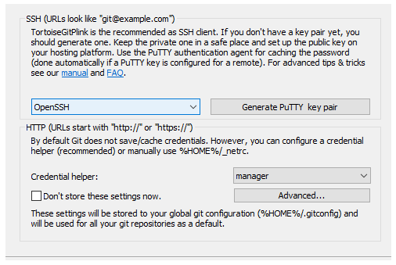

The Credentials can also be provided on the settings later.

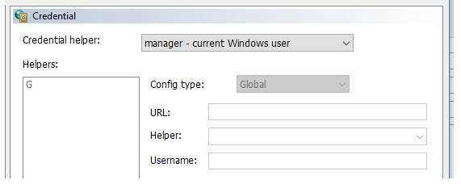

Once GIT is completely installed ,  you can create a repository as following :

1. Create a folder where you want to replicate the repository say (C:\OFARepos)
2. When you right click you should be able to see the GIT menu

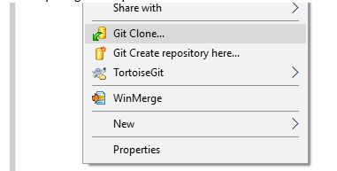

1. Click Git Clone , enter the test repository  “<https://sisopra.visualstudio.com/ISSSG_Training/DSI/_git/OFA_ModuleGL>” , The Directory would be your current directory where you want to create the repository .
2. When you click OK all the components of the OFA_ModuleGL shall be copied to your machine

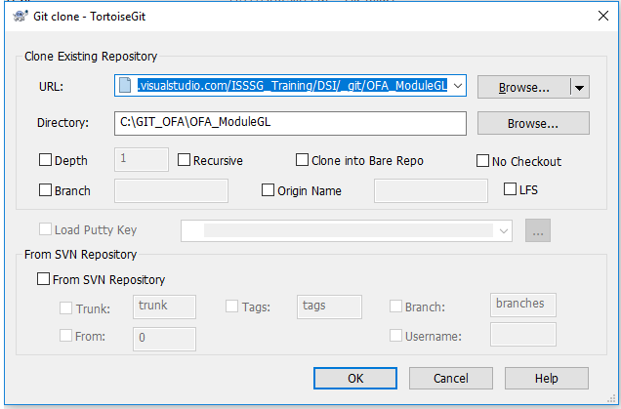

If GIT fails to connect please use the following proxy setup

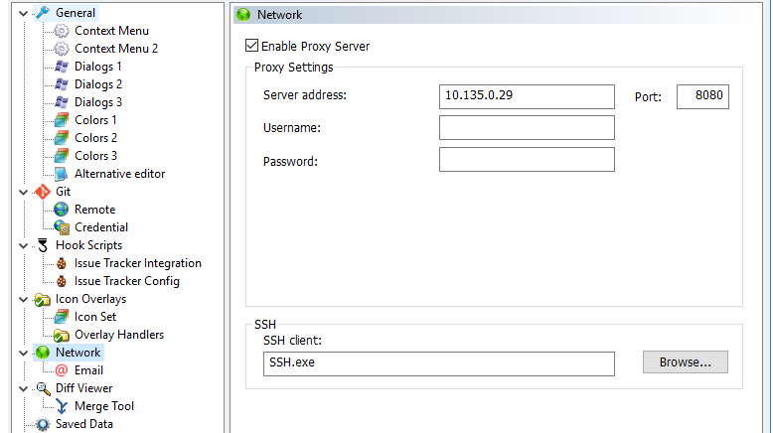

## Repository Links:

Training : <https://sisopra.visualstudio.com/ISSSG_Training/DSI/_git/OFA_ModuleGL>

AP : <https://soprasteria-is.visualstudio.com/ISSSG/_git/OFA_AP>

GL : <https://soprasteria-is.visualstudio.com/ISSSG/_git/OFA_GL>

… To be Completed

## Check in Process :

## Different GIT directories as available for each module on the server as well as on your machine when you clone it.

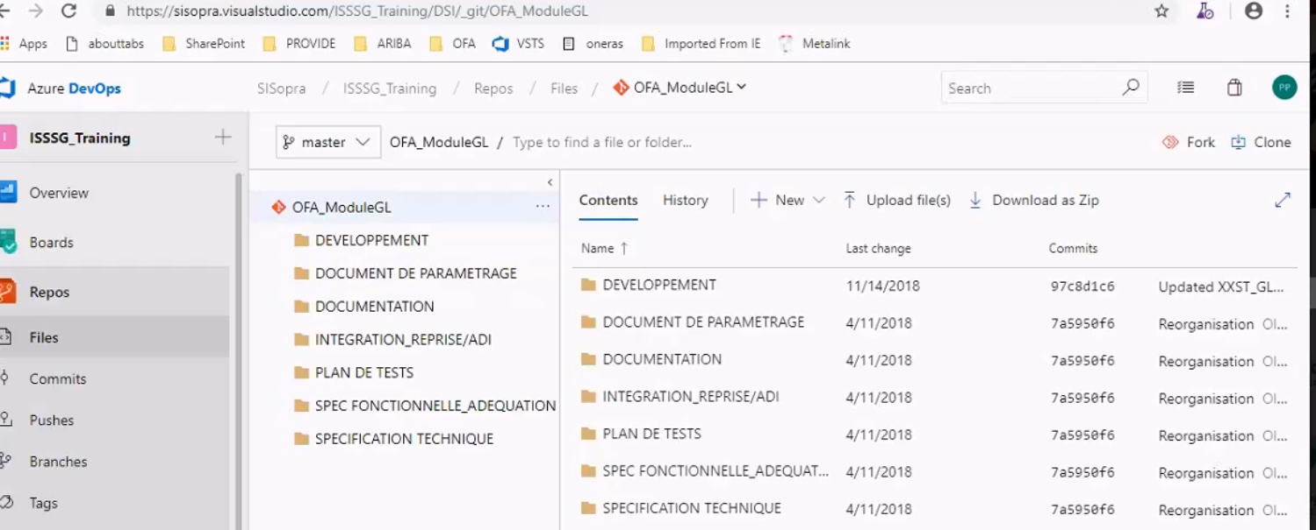

* + - 1. The green tick sign shows that the Repository is in the right synced condition.

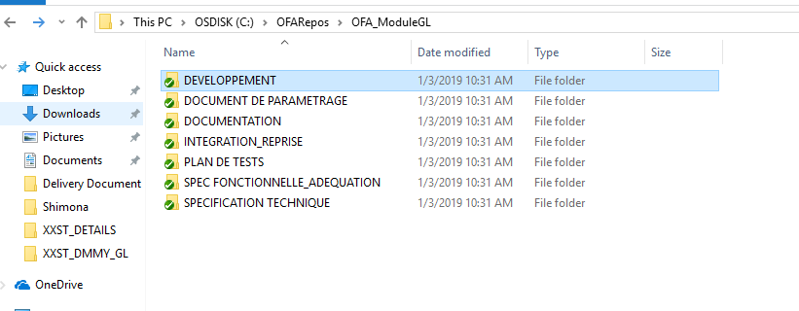

* + - 1. Now suppose we want to upload a file, lets say we want to upload a RDF , we will go to

**DEVELOPMENT 🡪 REPORT 🡪 US**(The folder in which you wish to place your file) on my local machine.

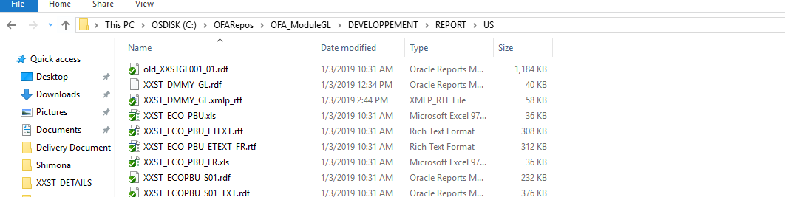

4. Now we have to update this file on the server , right click on the file and click on GIT Commit.

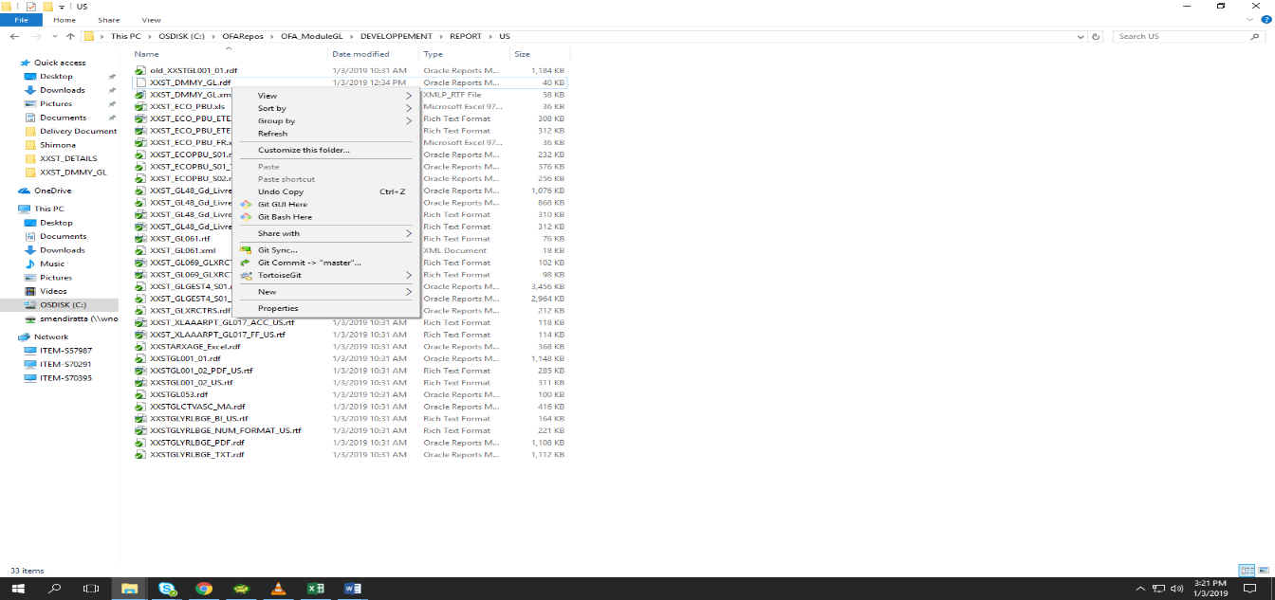

1. . Once we click on GIT commit , following window will open

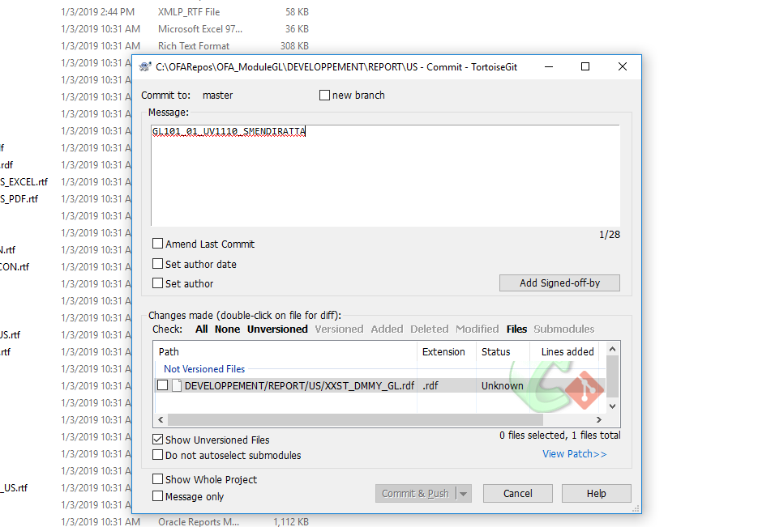

Here in the Message :

We write : **GL101_01_UV1110_SMENDIRATTA**

* **GL101 :** The specific Number against which we made the change
* **01:** The version number
* **UV1110:** The user voice against which the changes were made.
* **SMENDIRATTA:** The person who made the changes.

1. Click on Commit & Push. If we click on just commit then the changes will be committed and if we click on Commit & Push , the changes will be pushed to the server as well.

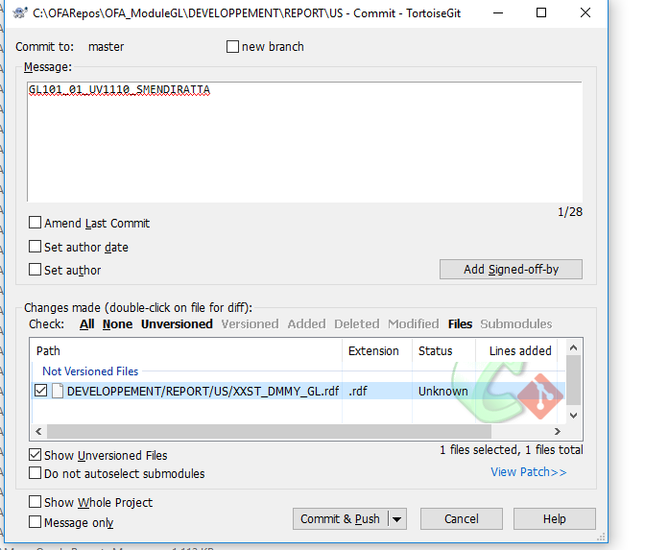

Click on Commit & Push

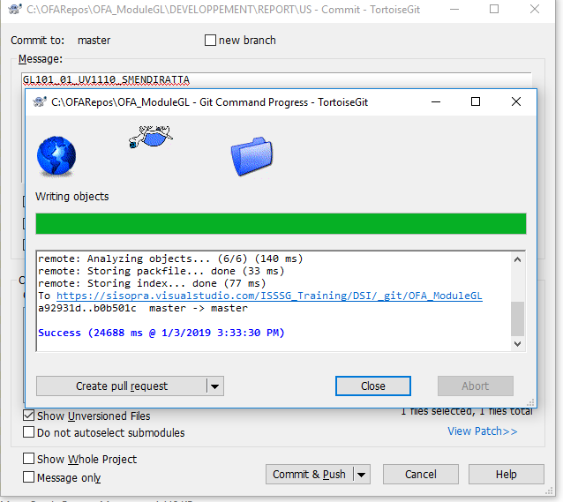

1. Finally , the file will be successfully uploaded on the server. Note the GIT Number.

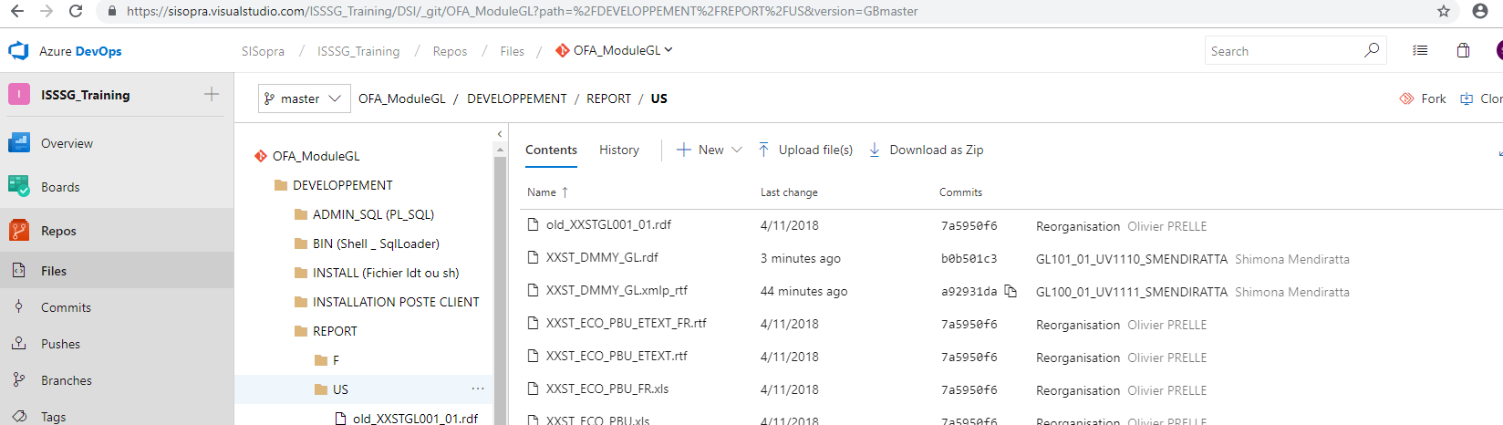

1. Now , we add the changes into the delivery document as well

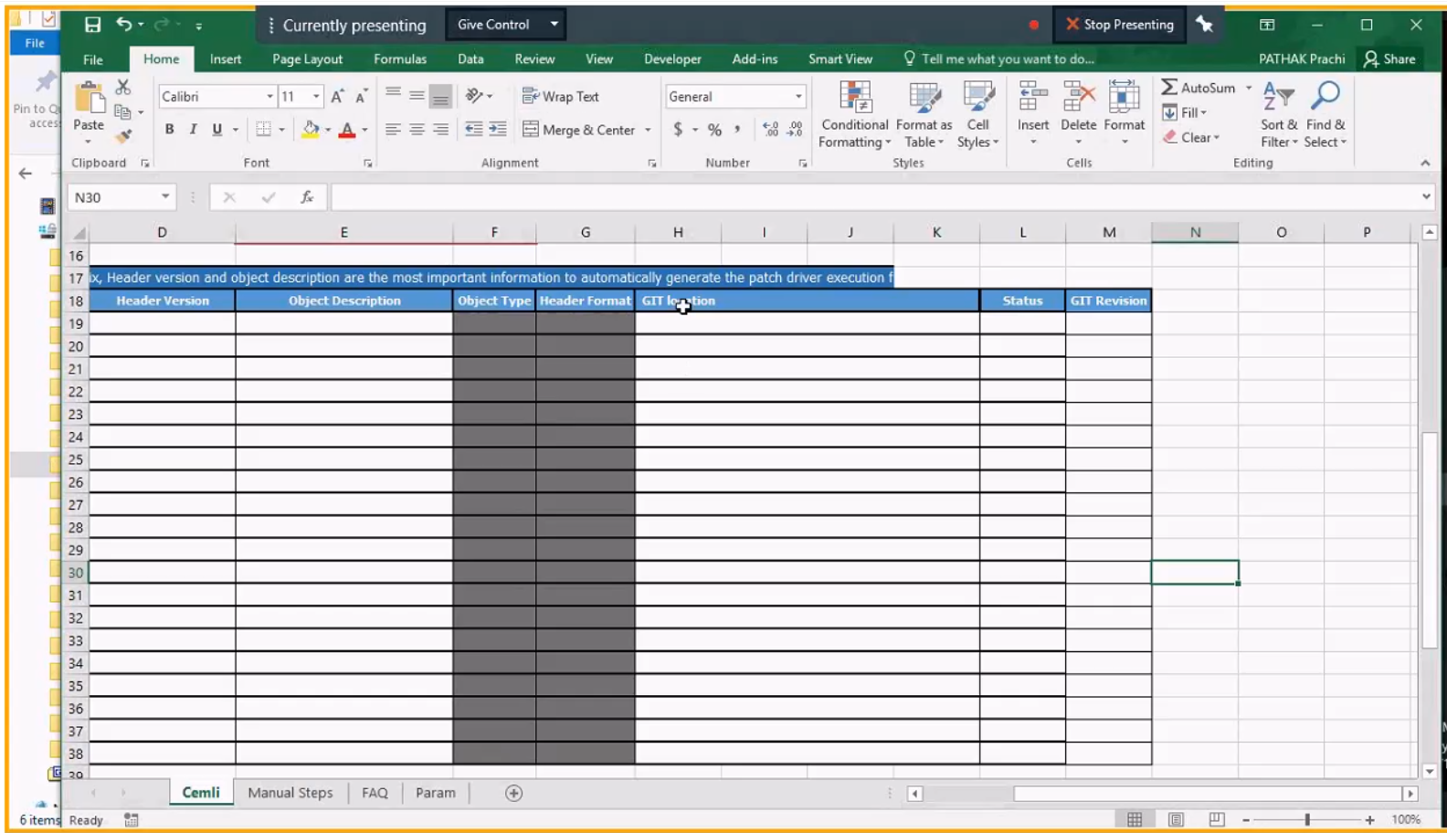

**GIT Location :** Is the Location of the file where the file is placed.

**GIT Revision :** Is the GIT Number. For Example, in the above mentioned case , GIT Number was b0b501c3.

# ACE Delivery

## Pre-Requisites

Some of the pre requisites for ace delivery can be :

1.The file header is very mandatory in any of the components being added to ACE portral.

2. The version number is very important and also the version number should be updated if the same file is being uploaded again. The version number should be up to date.

3. The format for the header and patch number should not be changed. It should remain the same for any component being added.

4. Parallelly the version number and patch number has to be updated on the delivery document as well.

## File Headers

While uploading any file on the Oracle ACE Portal , file header should be mentioned in each and every file.

**For instance**

* While uploading a SQL script the header be like :-

REM $Header: XXST_PAE67.sql 001.003.000 2018-12-18 Ankur Joshi $

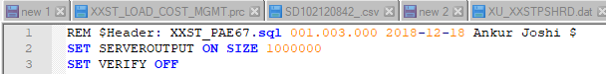

The number highlighted in blue is the version number. If we upload the same file for the second time ,

the version number will then be increased. And this process will continue as many times the same file is being uploaded on the server.

* The file to be uploaded is RDF, so the header will be added in the **Comment section** of the **Property Inspector** of **Report Builder**.

Header be like : - $Header: XXST_DUMMY.rdf 001.000.000 2018/12/24 00:00 SHIMONA$

* The highlighted part is the version number .

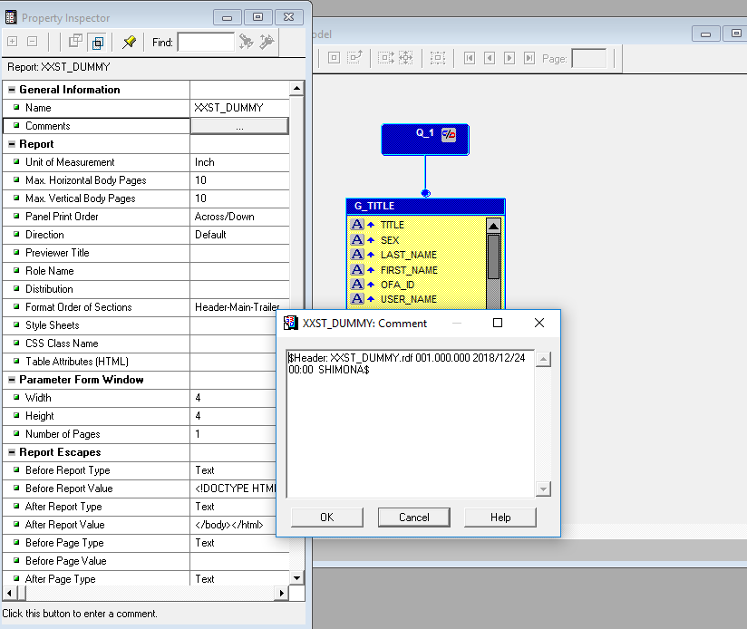

* If the file is to be uploaded is RTF , then also the header has to be added and the file extension will be changed. The extension will change from **.rtf to .xmlp_rtf.**

**NOTE :- Only after adding the header in the RTF in the comment section present in File menu 🡪 Info , change the extension of the file to .xmlp_rtf else the haeder would not be added.**

Header be like : $Header: XXST_DUMMY.xmlp_rtf 001.000.000 2018-12-24 SHIMONA $

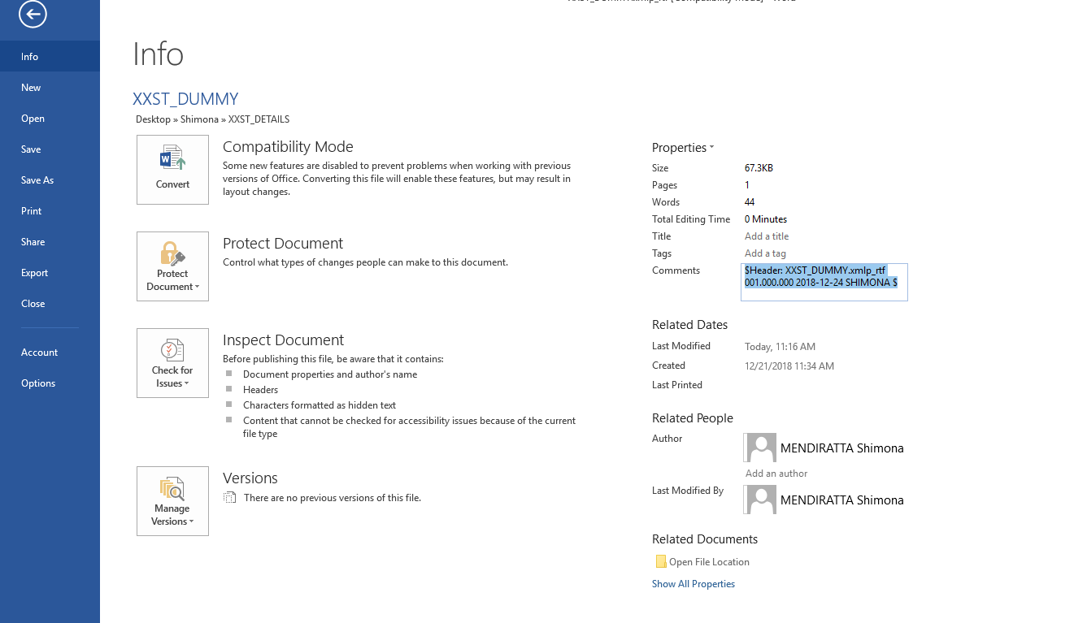

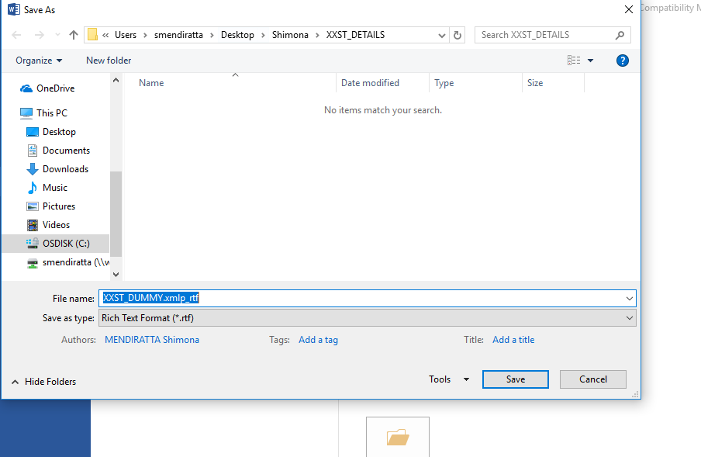

## Uploading file and creating Patches

1. Click on **Managed Cloud** 🡪 **Cemli**

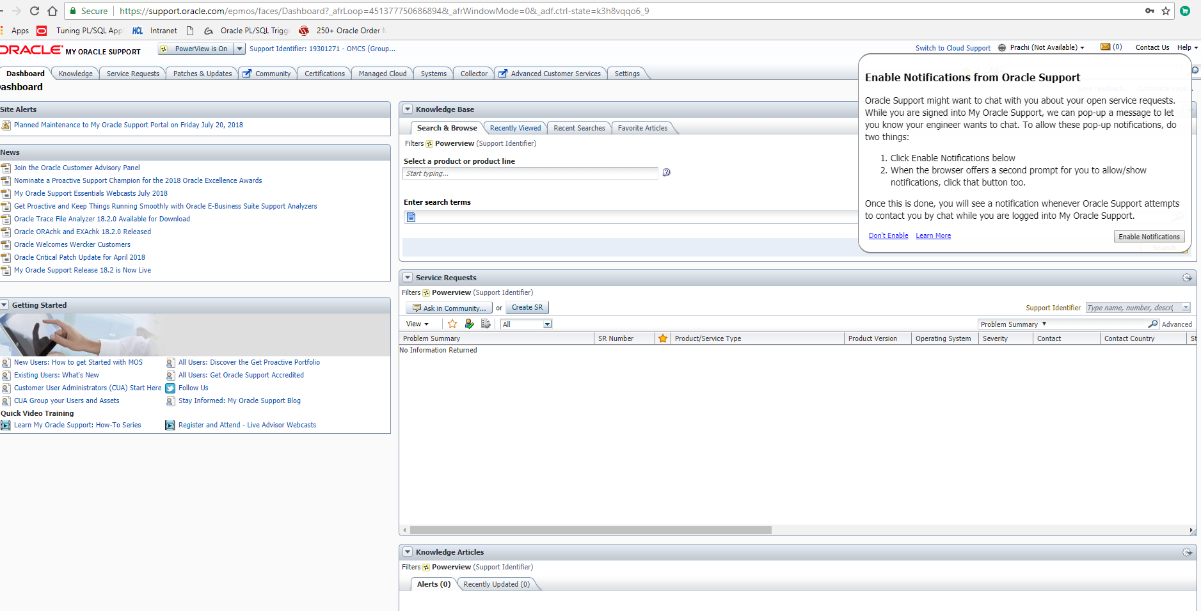

1. 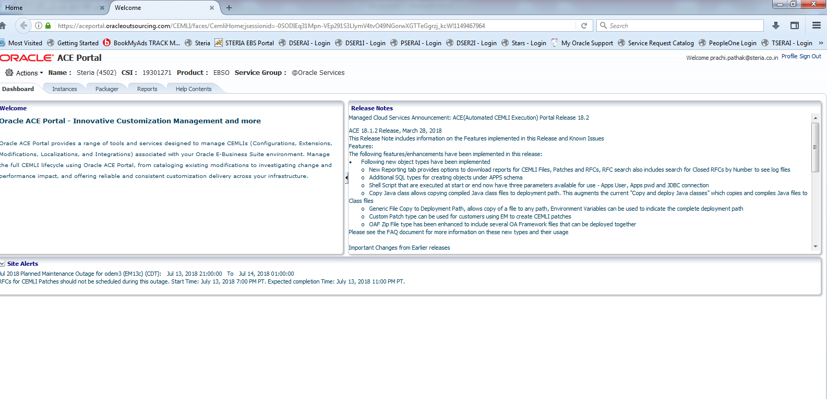Click on **Packager**
2. Click on **Add all file**. Then add the description, Format will be (AP100 – as this is an example for payables) According to the module AP, AR , FA the name will be changed accordingly.

**Note :**

While uploading any file , whether a RDF , RTF , XML , etc. , there is a header to be added in the so that it can be uploaded on the ACE Portal. Also, the extention also changes in some cases. The details of each header and its extentions are given in the delivery document.

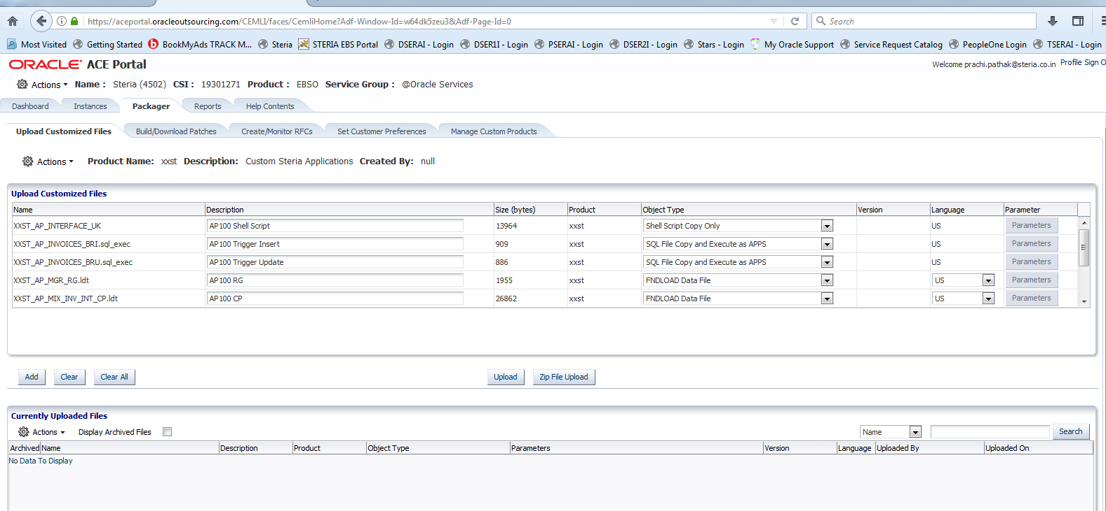

* 1. **For delivery of Java and BC4J components(12.2.x):**
     1. 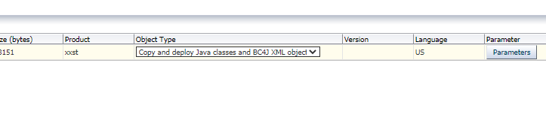Choose the object type as ‘Copy and Deploy Java classes and BC4J XML objects’.
     2. 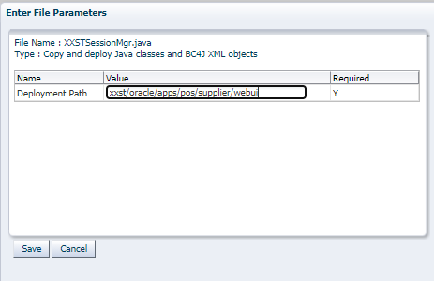Click on Parameters and provide the Deployment Path value

1. Click on **Upload**🡪 **Start Upload**.
2. Click on **Build/download Patches** and then choose your uploaded files
3. Patch name format should be as ‘AP100_01_UV9404_01’ where
4. Patch Description : AP100_01_UV9404_01

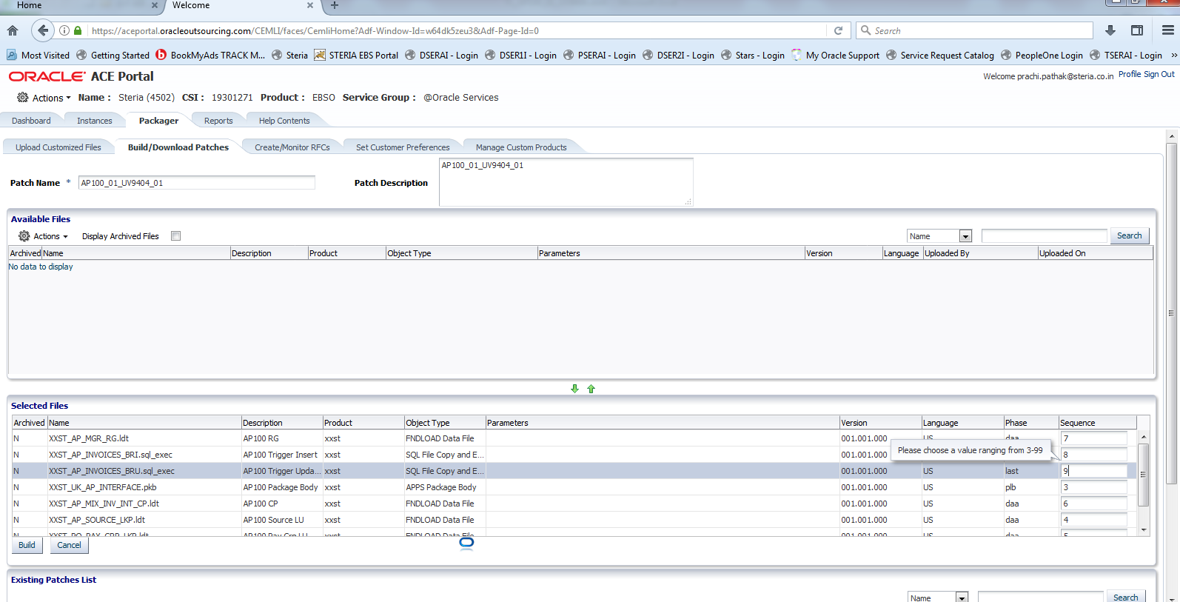

1. Click on down arrow🡪 enter the patch name🡪Patch Descriptions🡪 then insert the sequence🡪 then Build -- this is for build a patch
2. For deploying Java files, please click on the ‘Generate Jar’ checkbox, which will run the adcgnjar utility and reaerate the customall jar.

**NOTE : - >**

* **Patch Name is** object_number+version_number+user_voice+file version

**Example :** AP100_01_UV9404_01

* Object_number: AP100
* Version_number: 01
* User_voice/Bug Reference Number : UV9404
* File version : 01

1. Patch description would be same as patch number.
2. Copy the patch number and keep it with you for further use.

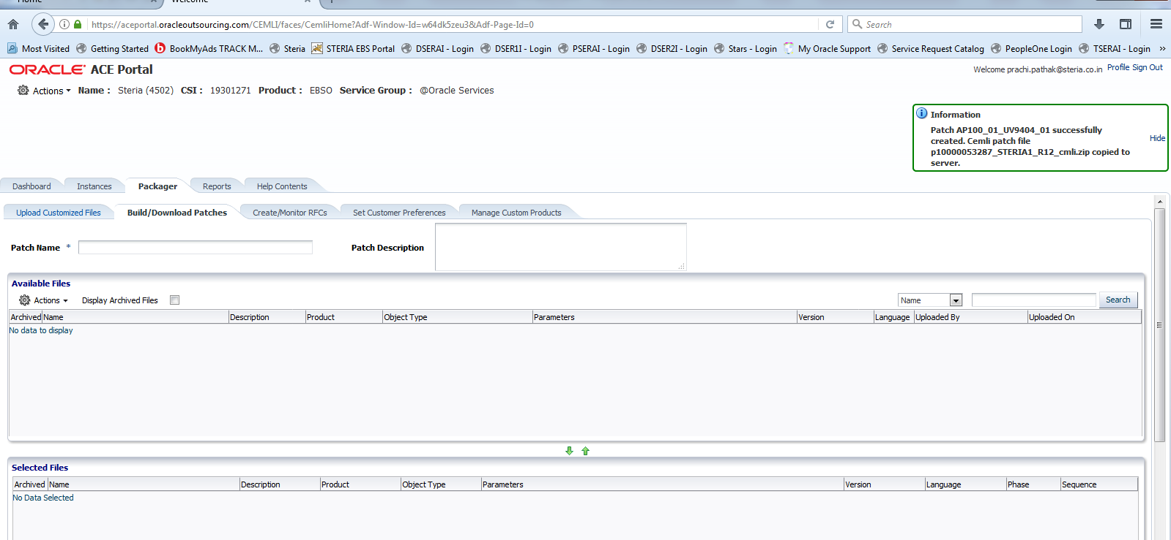

1. It will show a message, save that message on your local machine.
2. Then click on **Create Monitor RFC**

## Applying RFC

1. Click on **Create Monitor RFC**

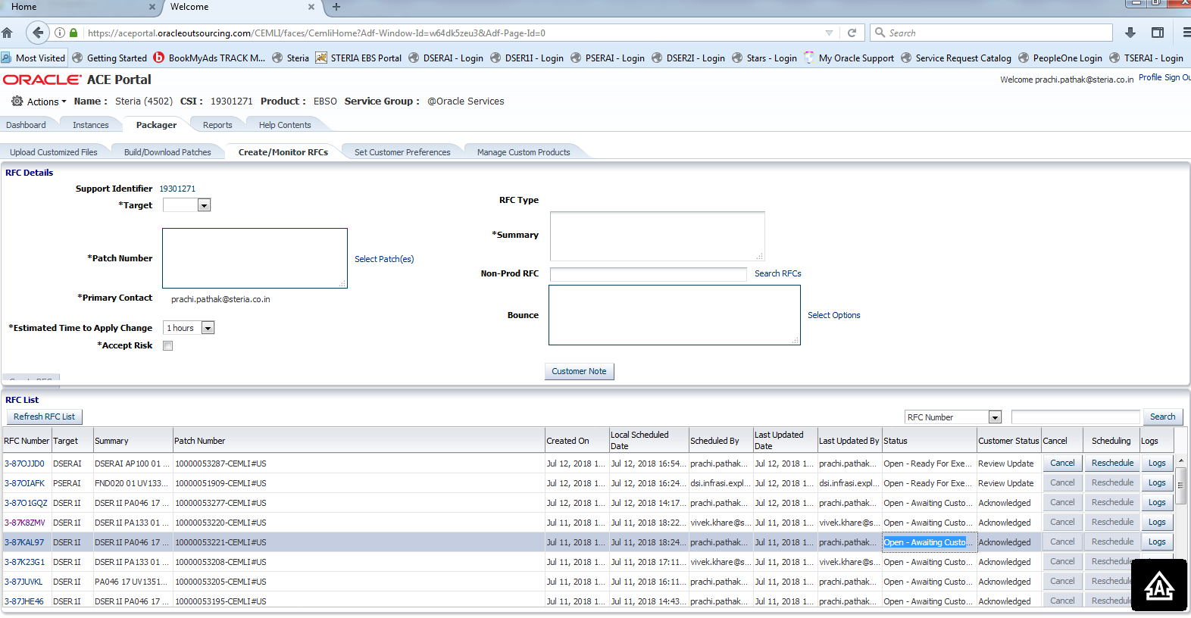

1. Select the Target for selecting the instance like (DSERAI , DSER1I, etc)
2. Select the patch by clicking on (**select patch(es)** ) and then insert summary

**Note :- The summary format should be (DEVELOPMENT PA100_01_UV9404_01)**

**Summary will be:-**

**instance+ object_number_+ version_number+ user_voice+ file version**

1. Check the **Accept Risk** buttonand a pop up will appear on the screen which will show the estimated time that it will take to run. Click on **OK.**
2. Click on create RFC button

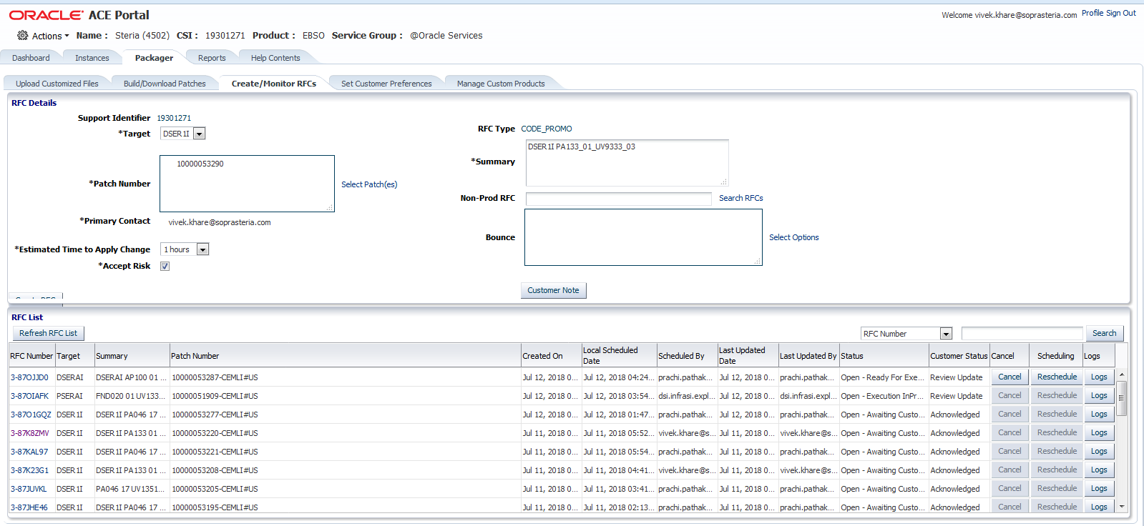

1. To keep the track of the patch status click on ‘Refresh RFC List’ button after given estimated time.

**Status :**

* **Acknowledged** means that the patch has been uploadedand also u check the updated status by clicking on RFC Number 🡪 Notes.

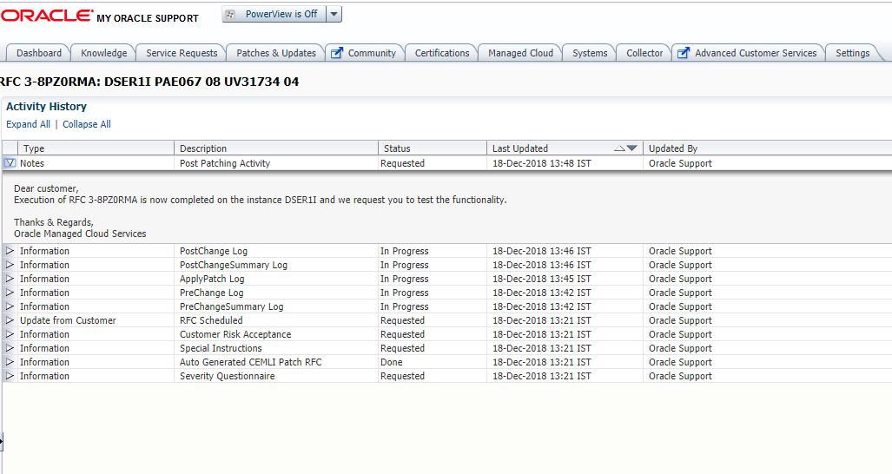

* **Review Update** means that the uploading is under process**.**

1. After the status is **ACKNOWLEDGED ,** you can test the patch on the targeted instance.

# Delivery Sheet

For each delivery a delivery sheet need to be initiated . The File should be placed on share point at following location in the respective module

<https://steria.sharepoint.com/:f:/r/sites/DOCIS/Shared%20Documents/Applications/Finance?csf=1&e=FFWp5P>



Naming Convention : FL_XX00_00_UV99999.xlsm (FL_AP093_01_UV123456.xlsm)

* The delivery document has to be updated after every component being moved to any of the instances and it has to be kept up to date.

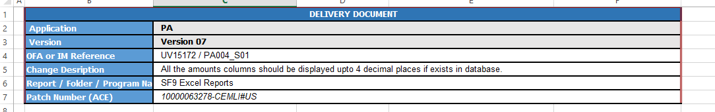

* **Application:** The module which is being deployed whether it is PA, FA, GL, AP.
* **Version:** The version of the document. ( same as mentioned on the header)
* **OFA Or IM Reference:** The user query number.
* **Change Description:** Briefly explaining the change that has been made in the report/ concurrent program or any of the component.
* **Patch Number (ACE):** Generated by the ACE Portal.
* Then after filling the above information in the document, now we fill the updated versions and dates of the component. The details of both DEVELOPMENT and DSER1I has to be added here.

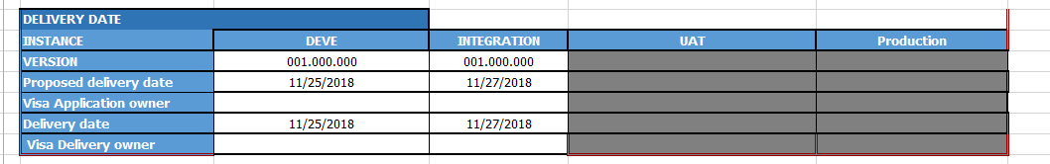

* **Version:** The version that has been mentioned in the header of the file being moved.
* **Proposed Delivery Date:** The proposed date by which the component will be moved and changes will be deployed.
* **Delivery Date:** The date on which the changed were last updated and deployed in the system via ACE portal.
* The component list to be delivered must also be mentioned in the delivery document.

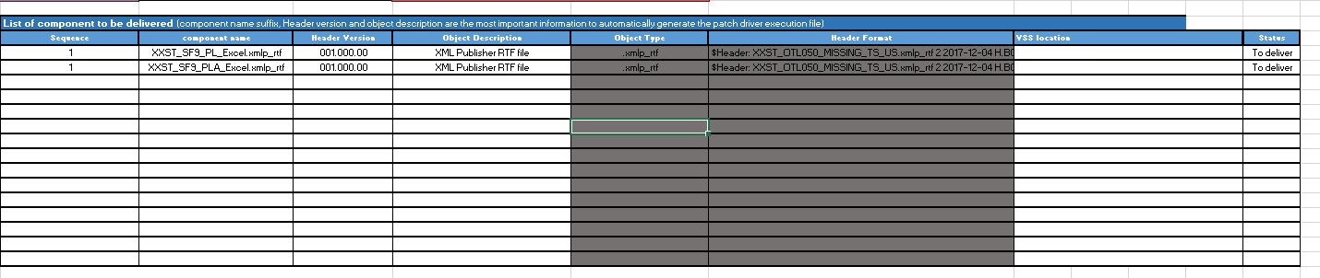

* **Sequence:** Sequence is the sequence in which the components will be moved in the system. For instance to move a concurrent program, first the executable has to be moved, then the concurrent program should be moved in the system. So, here in ACE Portal all the components has to be added sequentially and hence the delivery document has be updated sequentially only.
* **Component Name:** Component names are the names of the components that are being moved via ACE portal.
* **Header Version:** It is the version that has been mentioned on the file header.
* **Object Description:** Description of the component as to whether it is a RDF, XML, RTF so on and so forth.
* **Object Type:** Type is again the extension with which file is saved and being moved.
* **Header Format:** The header that has been mentioned in the file.
* **Status:** the current and updated status of that particular component as to whether it is in “To Deliver” state or “Do Not Deliver” state.
* **GIT** Revision should be mentioned on the file.
* The Front page of the delivery document looks like this :

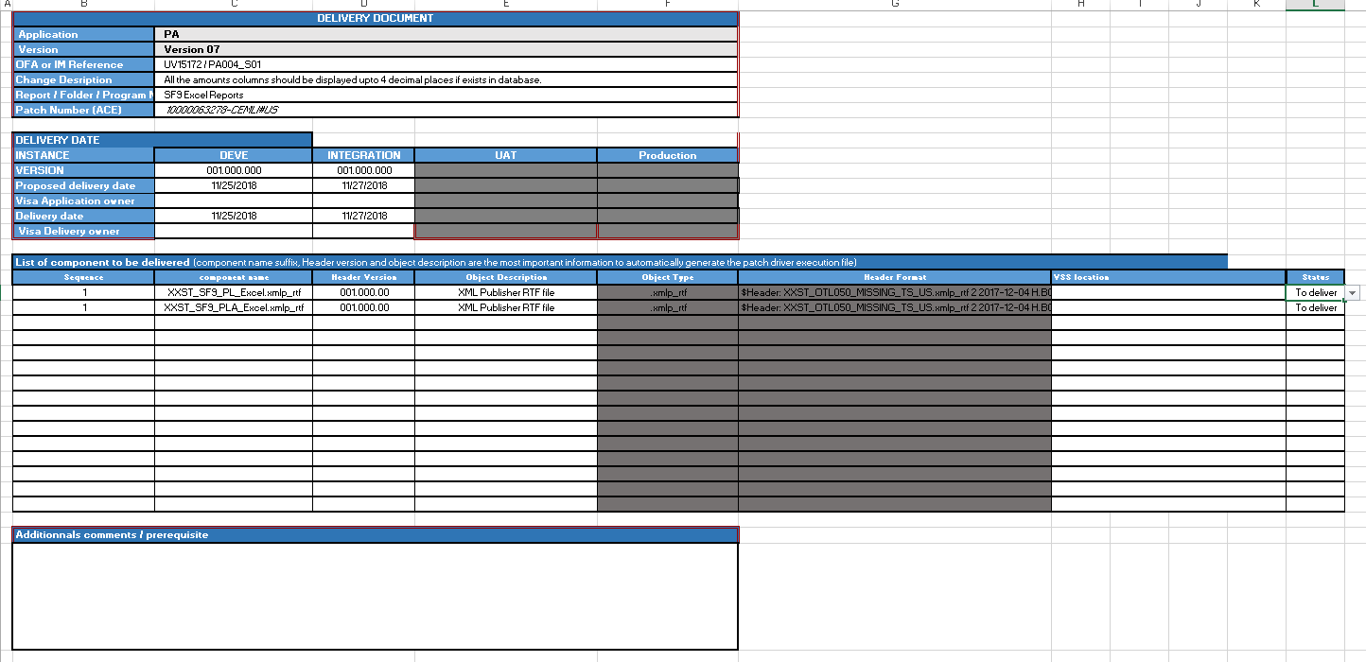

# MD070 documentations

The MD70 document is created to give the detailed technical specification of the developed component. It includes the following:

* Applicable or Reference documents
* Business Logic used for development of the component
* Technical Design – Approach used and list of objects created for the component
* Detailed Component Design – Description of the code and AOL objects developed
* Integration – Conditions to be considered while integrating the developed component with other modules
* Installation requisites – Installation scripts to be provided for successful installation of the component in the user testing environment (TSERAI) and production environment (PSERAI).
* All MD070 to be placed on Share Point at <https://steria.sharepoint.com/:f:/r/sites/DOCIS/Shared%20Documents/Applications/Finance/OFA_AP%20-%20Oracle%20Payables?csf=1&e=7awXUv> in respective module directory.

# FileZilla Setup

Steps to be followed for filezilla setup are-

1. Place the 3 .ppk file on your machine.
2. Go to Edit 🡪 settings

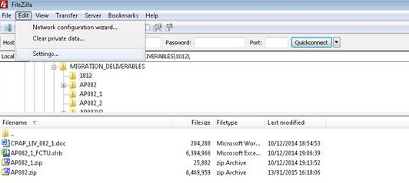

1. Select the node SFTP. Press Add keyfile to include each of the 3 files one by one.

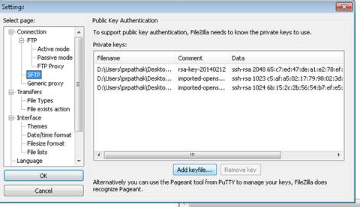

1. Go to site manager.

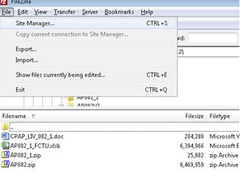

1. Two users need to be configured with server type SFTP here :

* J_SERA01 (Development Environments ) Host Name - vmohssera010.oracleoutsourcing.com – This user caters to all the non-prod environments viz. DEVELOPMENT (development)/DSER1I(integration)/TSERAI(UAT)
* I_SERA01 (production environment) Host Name - vmohssera011.oracleoutsourcing.com

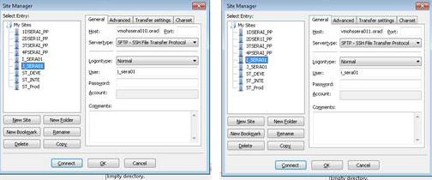

Link to Shared Drives:

\\wnoidufs02.noid.in.sopra\E\groups\IN-NOIDA3_SOEU____IN01\OFA-DSIGIN01\

Delivery Documents :

<https://steria.sharepoint.com/sites/DOCIS/Shared%20Documents/Forms/AllItems.aspx?csf=1&e=9khj3D&RootFolder=%2Fsites%2FDOCIS%2FShared%20Documents%2FApplications%2FFinance&FolderCTID=0x012000369FDFF4AC299A468C07420989E03B10>

Support Documents:

<https://steria.sharepoint.com/sites/DOCIS/Shared%20Documents/Forms/AllItems.aspx?csf=1&e=9khj3D&RootFolder=%2Fsites%2FDOCIS%2FShared%20Documents%2FApplications%2FFinance&FolderCTID=0x012000369FDFF4AC299A468C07420989E03B10>

Software Patches:

\\wnoidufs02.noid.in.sopra\E\groups\IN-NOIDA3_SOEU____IN01\OFA-DSIGIN01\downloads